Computation #7 Practice Name:_________________________________________

***Show your work and circle your final answer****

1. What is the sum (sum means +) of 6909 and 7567?

2. The difference between 99803 and 4896 is?

3. The total number of minutes in 15 hours is?

4. How many quarters are in $24.00?

5. The sum of 2450 and 560 and Y is 3025. What is the value of Y?

6. What is the sum of 85.5 and 12.5 and 13.75?

7. How many degrees in the missing angle C?

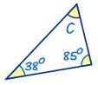

8. How many degrees in the missing angle X?

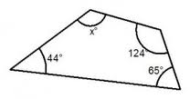

9. What is the angle between C –P– D?

